**Project Documentation**

**1. Introduction**

* **Project Title:** FitFlex
* **Team ID: NM2025TMID44268**
* **Team Leader:** MATHUMITHA A & mathumithankr@gmail.com
* **Team Members:**
* **HEMALATHA V &** [**nkrhema703@gmail.com**](mailto:nkrhema703@gmail.com)
* **DHANYASRI S &** [**sakhiyas310@gmail.com**](mailto:sakhiyas310@gmail.com)
* **DHANALAKSHMI P &** [**cithudhana@gmail.com**](mailto:cithudhana@gmail.com)
* **SHOBIKA S & shobika2007s@gmail.com**

**2. Project Overview**

* **Purpose:**  
  FitFlex is a fitness and wellness management platform designed to help users track workouts, set goals, monitor diet plans, and connect with trainers.
* **Features:**
  + Personalized workout and diet plans
  + Progress tracking with graphs
  + Trainer–student live chat & video sessions
  + Community support & challenges
  + Admin panel for trainer and user management

**3. Architecture**

* **Frontend:** React.js with Bootstrap & Material UI
* **Backend:** Node.js with Express.js
* **Database:** MongoDB (stores user profiles, workout logs, trainer details, chats)

**4. Setup Instructions**

* **Prerequisites:**
  + Node.js
  + MongoDB
  + Git
  + React.js
  + Express.js
  + Visual Studio Code
* **Installation Steps:**
* # Clone the repository
* git clone <repo-link>
* # Install client dependencies
* cd client
* npm install
* # Install server dependencies
* cd ../server
* npm install

**5. Folder Structure**

FitFlex/

|-- client/ # React frontend

| |-- components/

| |-- pages/

|

|-- server/ # Node.js backend

| |-- routes/

| |-- models/

| |-- controllers/

**6. Running the Application**

* **Frontend:**
* cd client
* npm start
* **Backend:**
* cd server
* npm start
* **Access:** Visit <http://localhost:3000>

**7. API Documentation**

* **User:**
  + POST /api/user/register
  + POST /api/user/login
* **Workouts:**
  + POST /api/workout/create
  + GET /api/workout/:id
* **Trainers:**
  + GET /api/trainers
  + POST /api/trainers/apply
* **Chats:**
  + POST /api/chat/send
  + GET /api/chat/:userId

**8. Authentication**

* JWT-based authentication for secure login
* Role-based access (Admin, Trainer, User)

**9. User Interface**

* Landing Page
* User Dashboard (Workouts, Diet, Progress)
* Trainer Dashboard
* Admin Panel
* Chat & Video Call Integration

**10. Testing**

* Manual testing during development
* Tools: Postman, Chrome Dev Tools

**11. Screenshots or Demo**

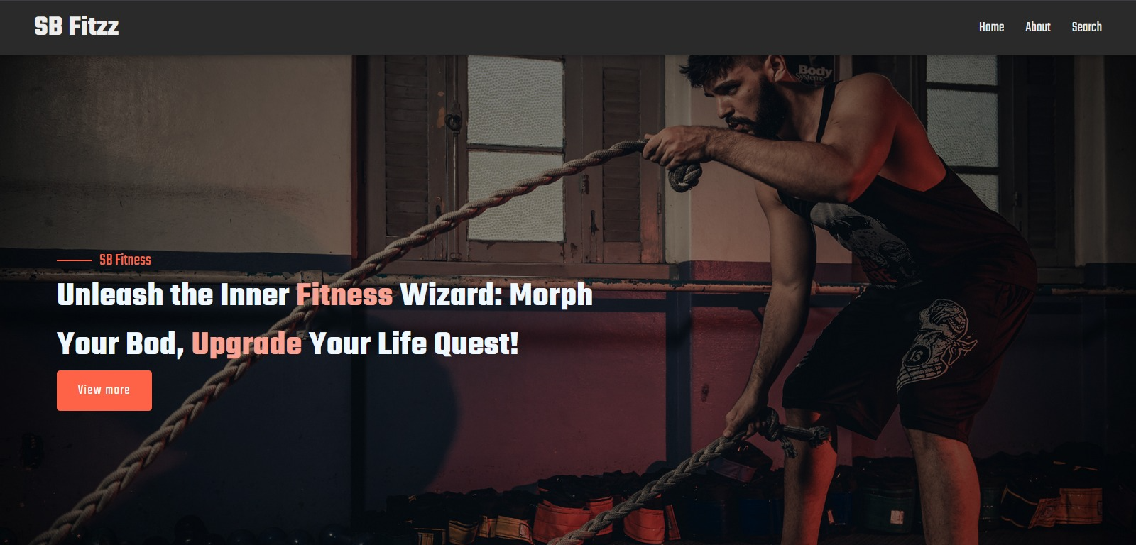

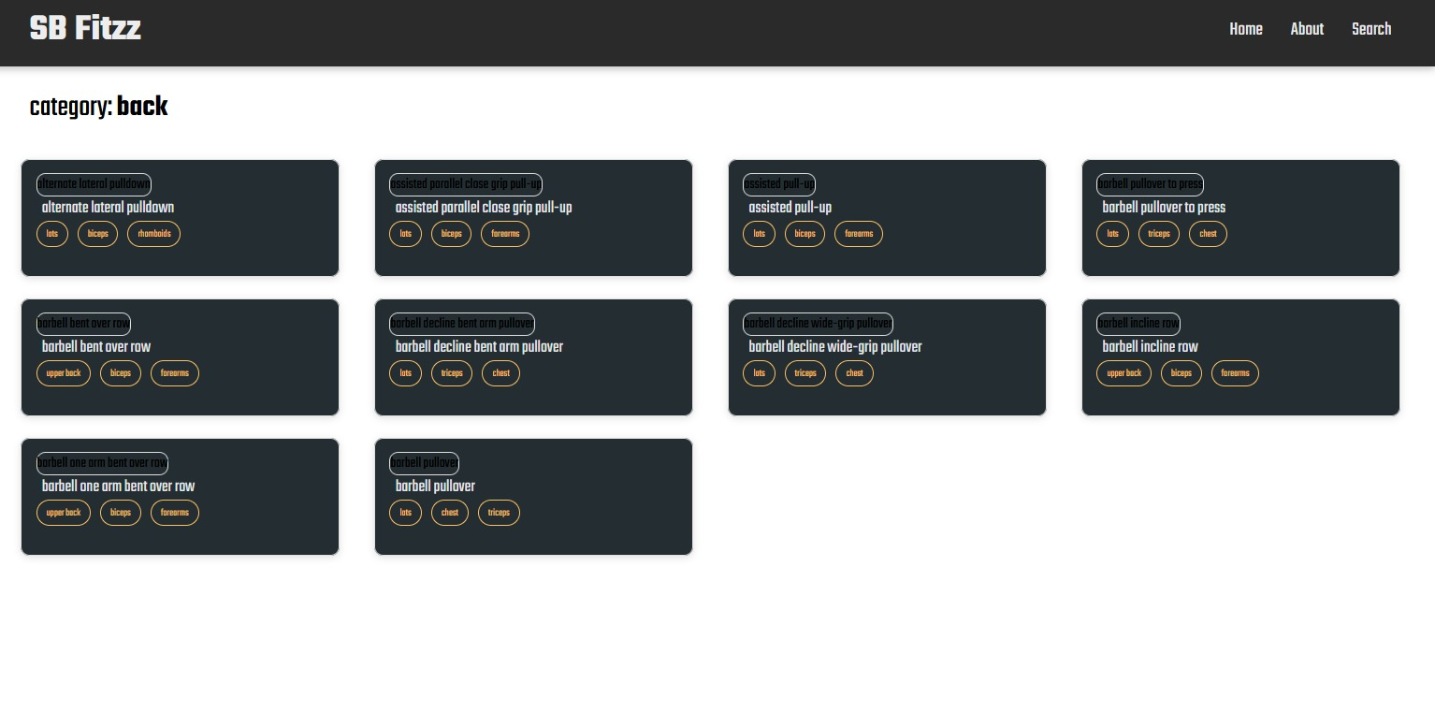

**12. Known Issues**

* Limited offline support
* Video calls may lag on low internet speeds

**13. Future Enhancements**

* AI-based personalized fitness recommendations
* Integration with smart wearables (Fitbit, Apple Watch)
* Group fitness challenges with leaderboards

Top of Form